# Goals

Create an API with api gateway

Use a VPC link to secure traffic

End result:

You can now use https so traffic is more secure

EC2 is less exposed to the internet

# Create API Gateway

### Create the HTTP Gateway

Click on build

## 

Use these settings. Add the endpoint with the port to your EC2 Instance

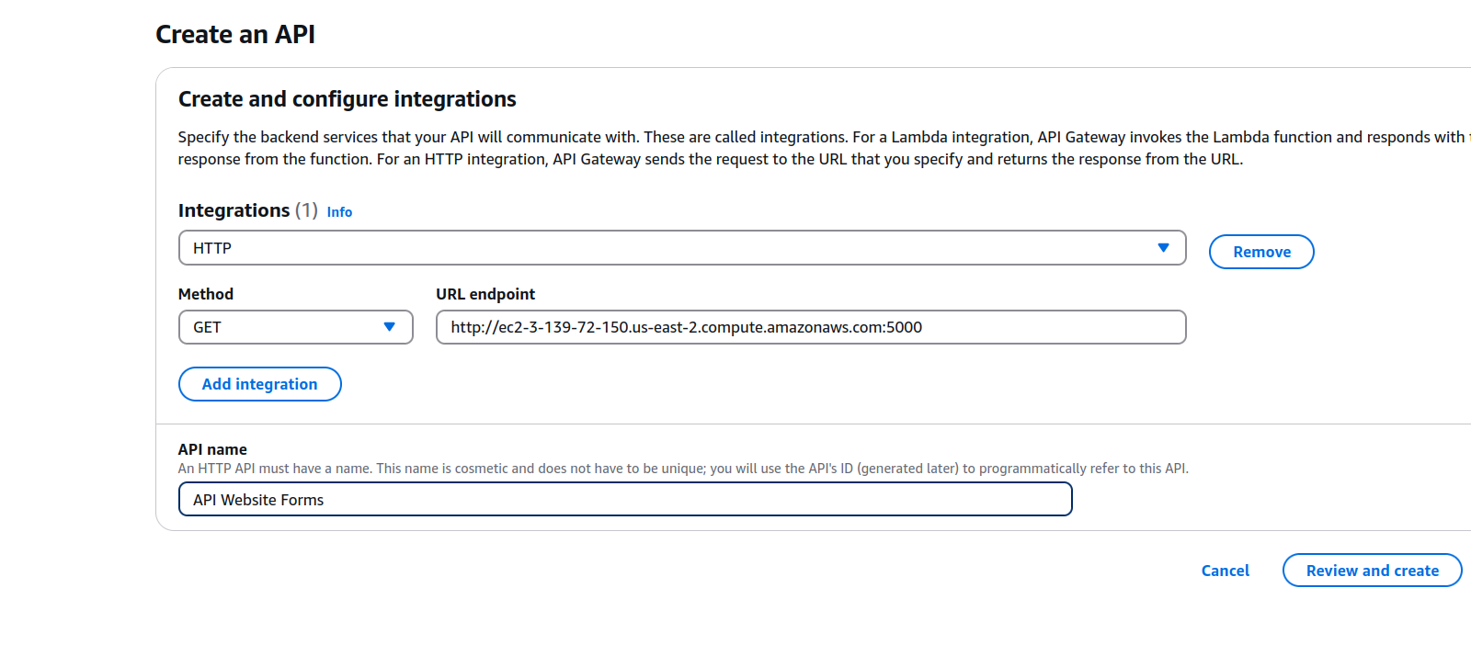

We will be using the base path / resource.

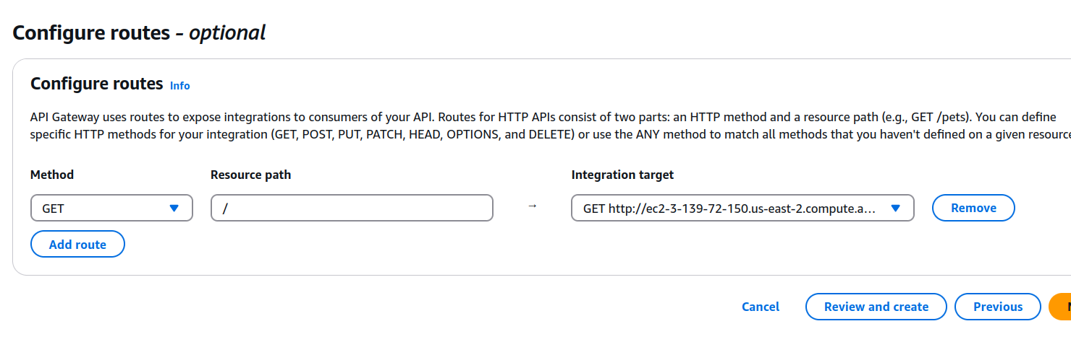

Go through the rest with default settings and click create

## Test it out

Connect to your api through the default endpoint, located in the API tab

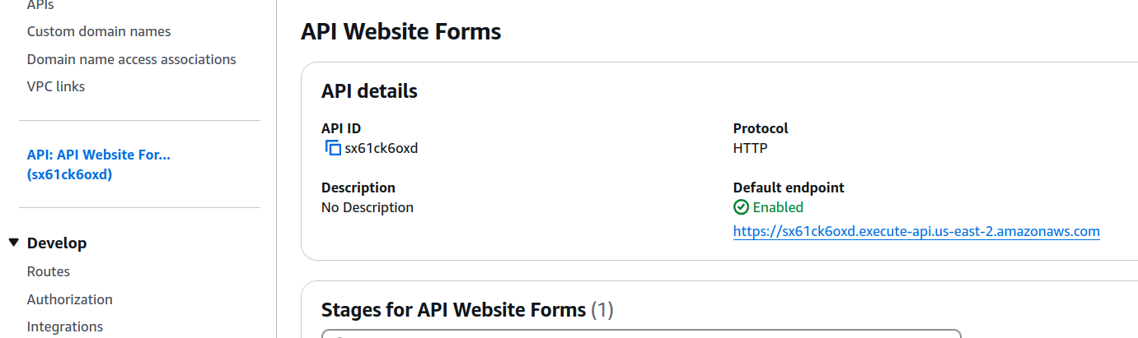

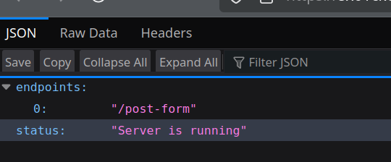

## Create post-form route

### Create a new route

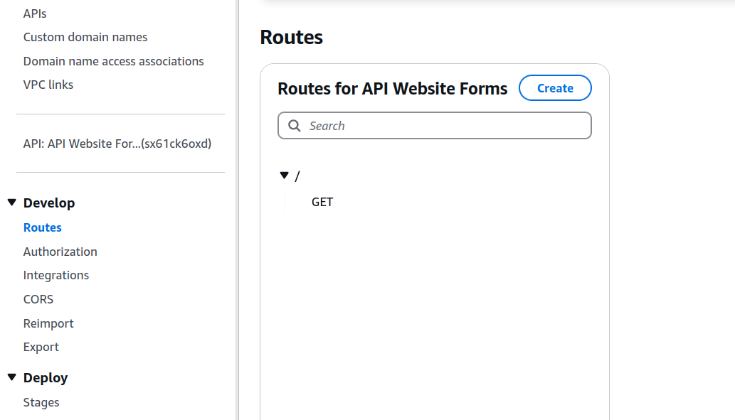

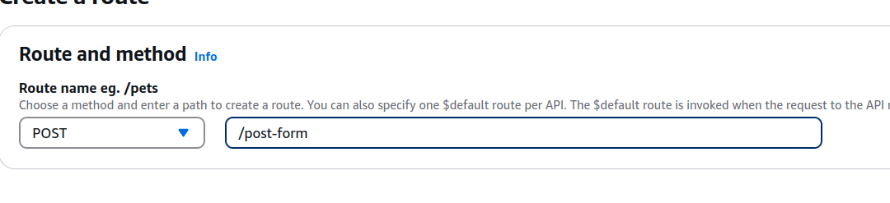

### Add the integration

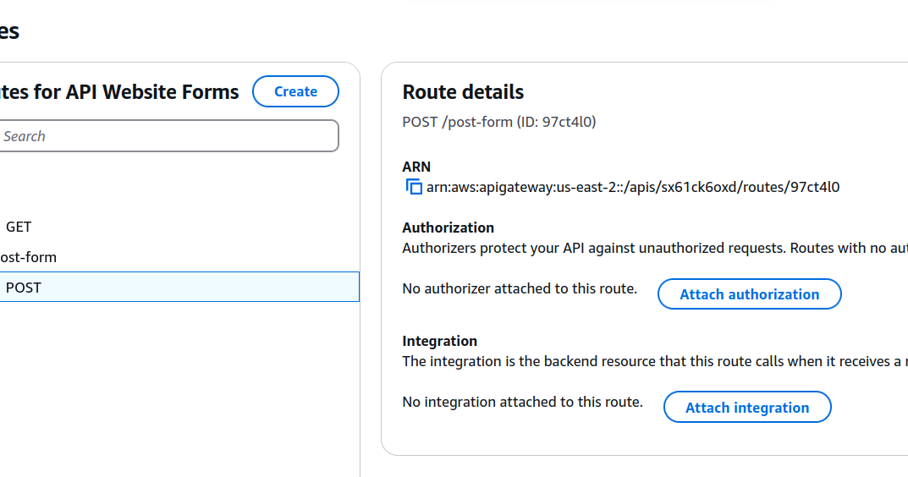



Add the url. Don’t forget the http.

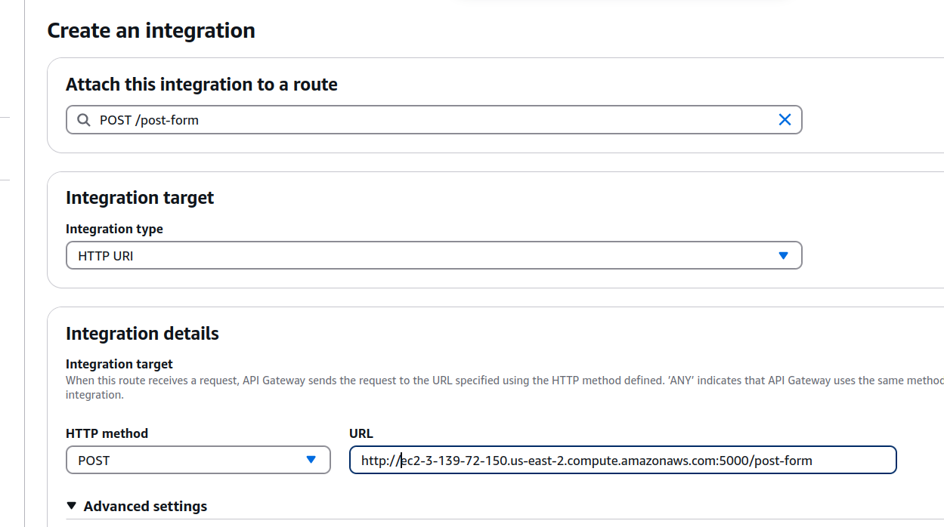

Go back to your index.html and replace the form action with your post form api.

Congratulations.

## Creating a target group

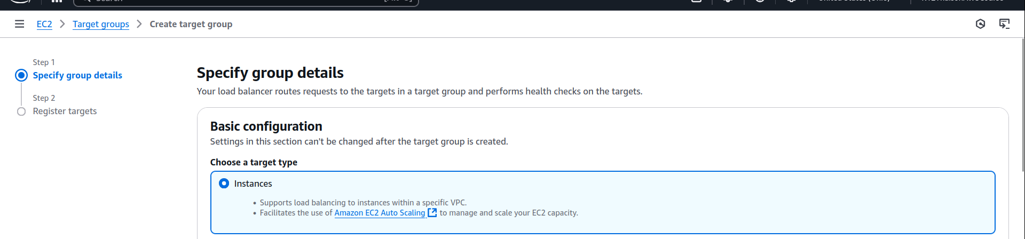

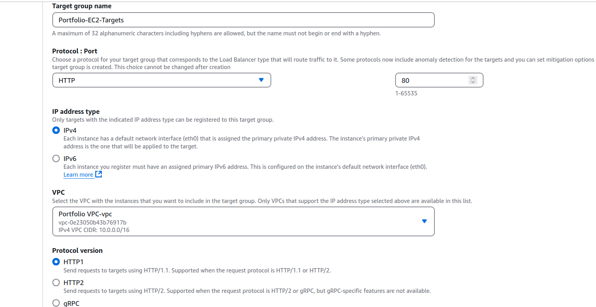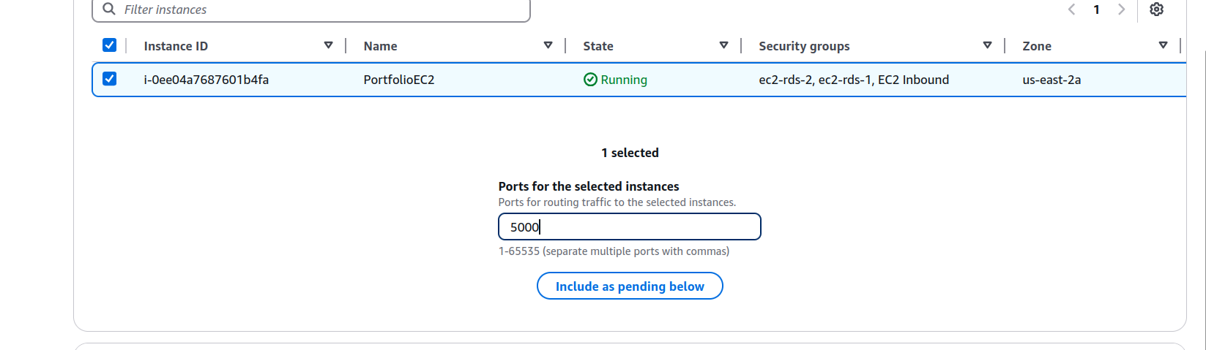

## Creating an application load balancer

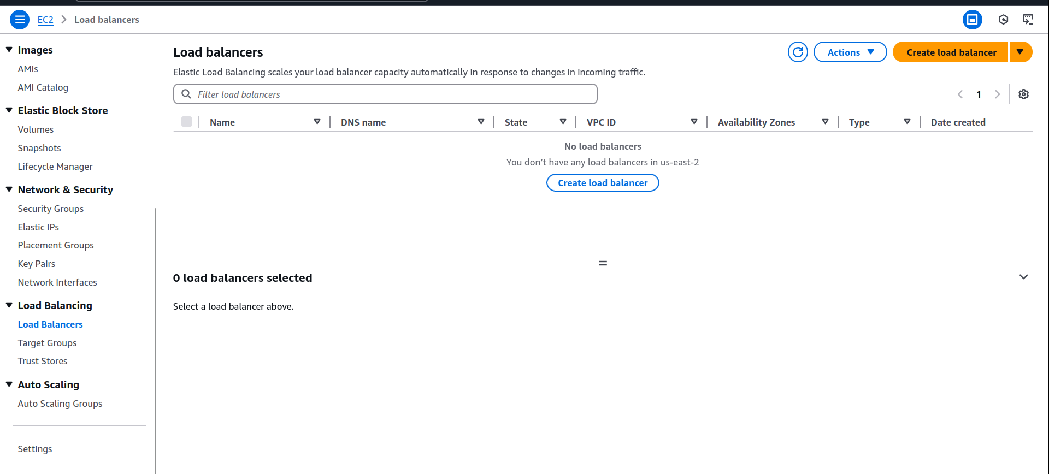

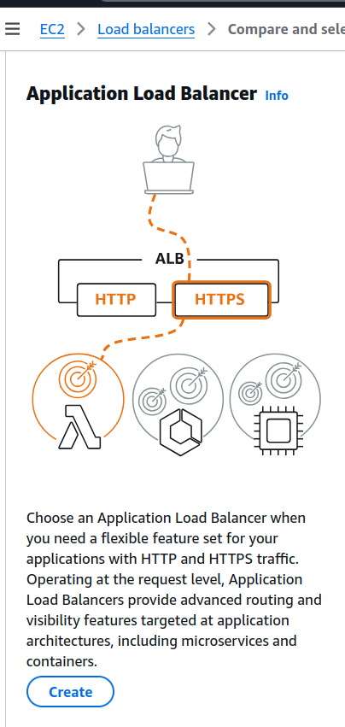

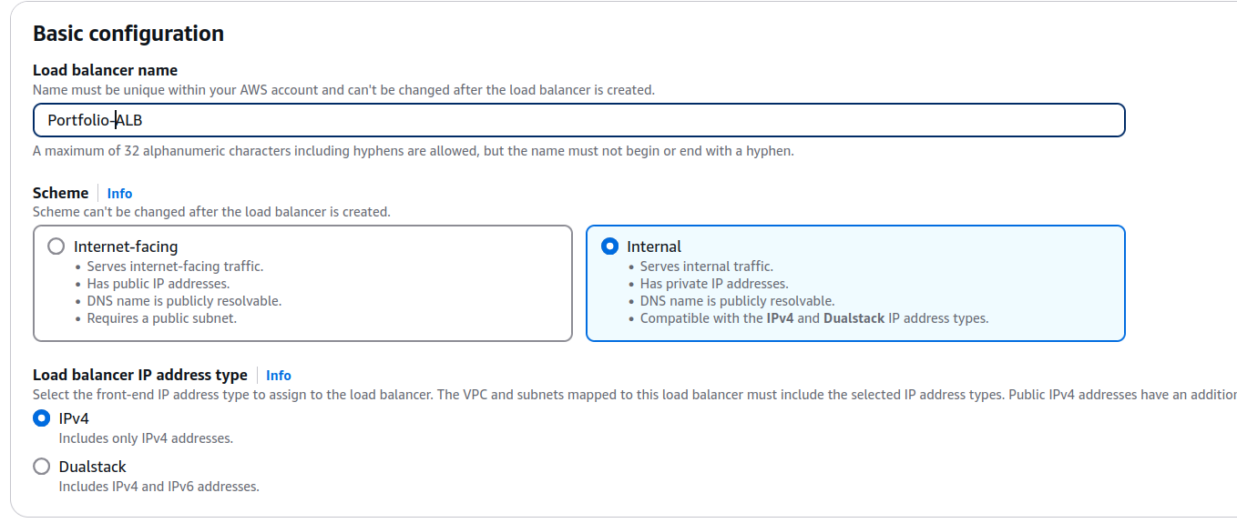

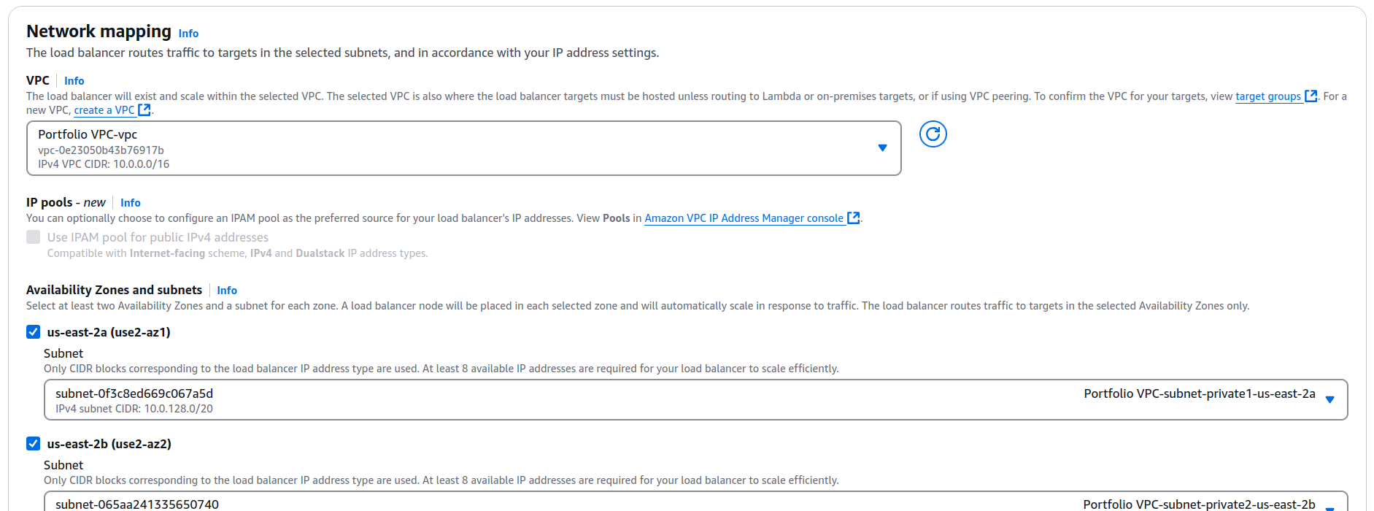

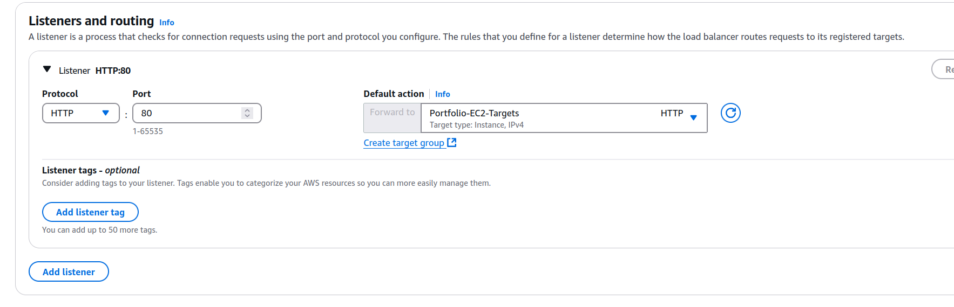

## Creating a VPC Link



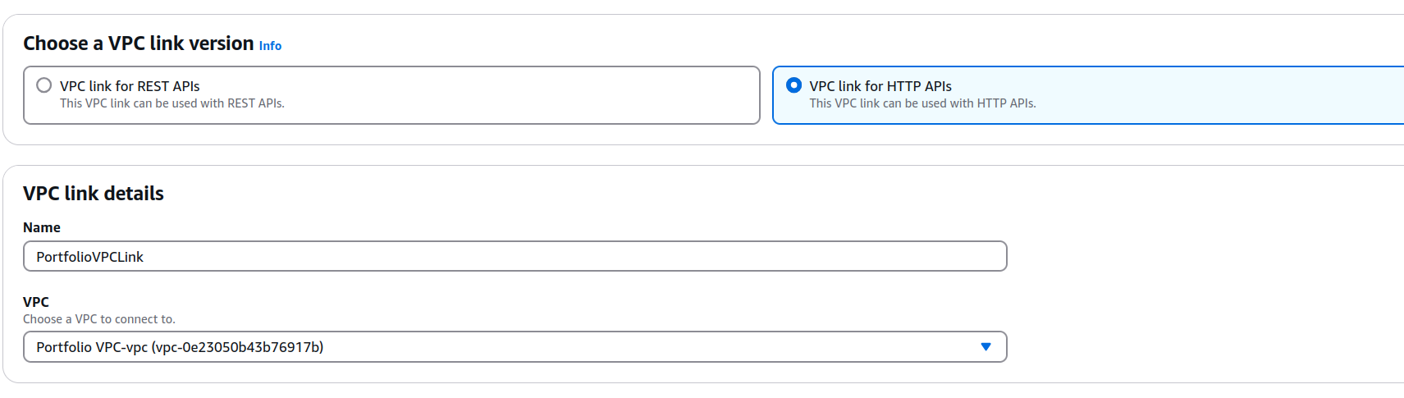

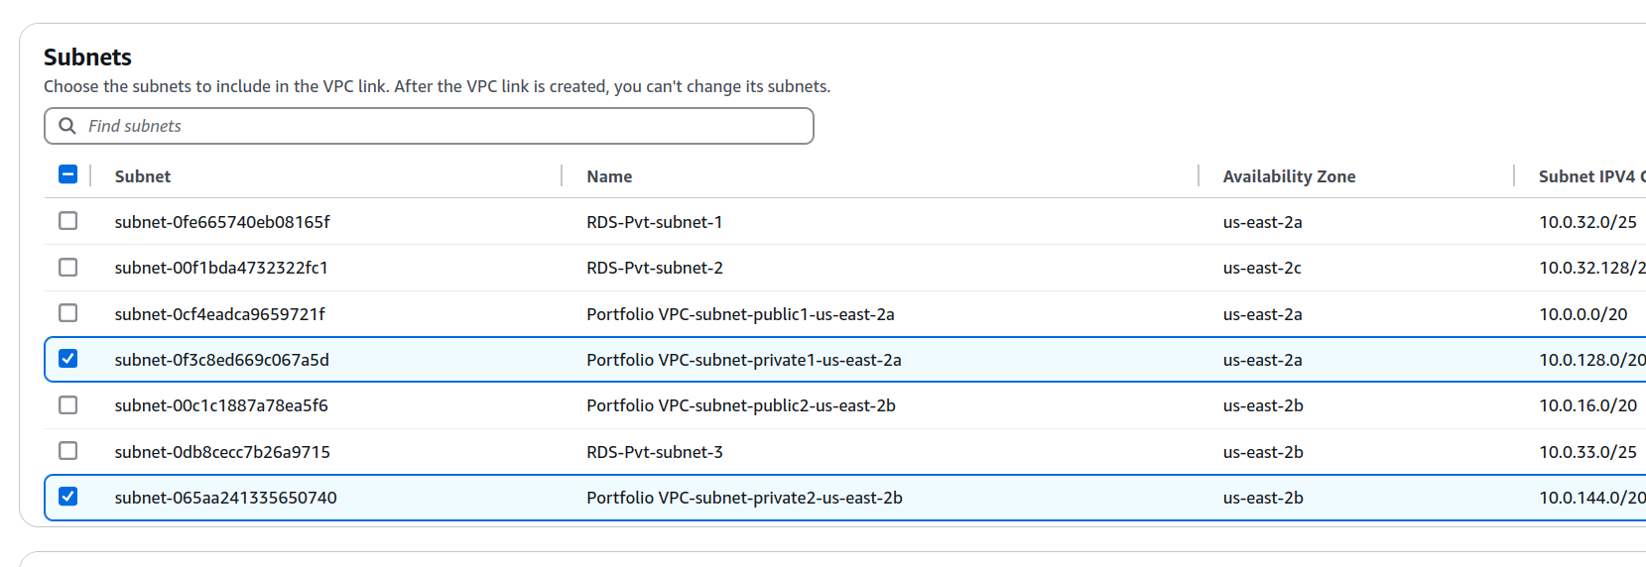

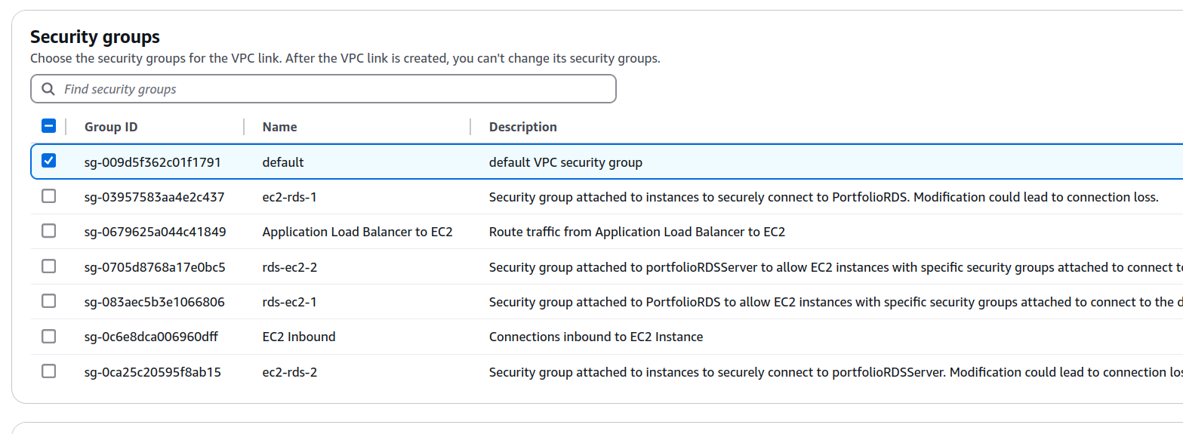

## Creating a more private route

### Create a new integration for route /

Detach the old integration and create a new one

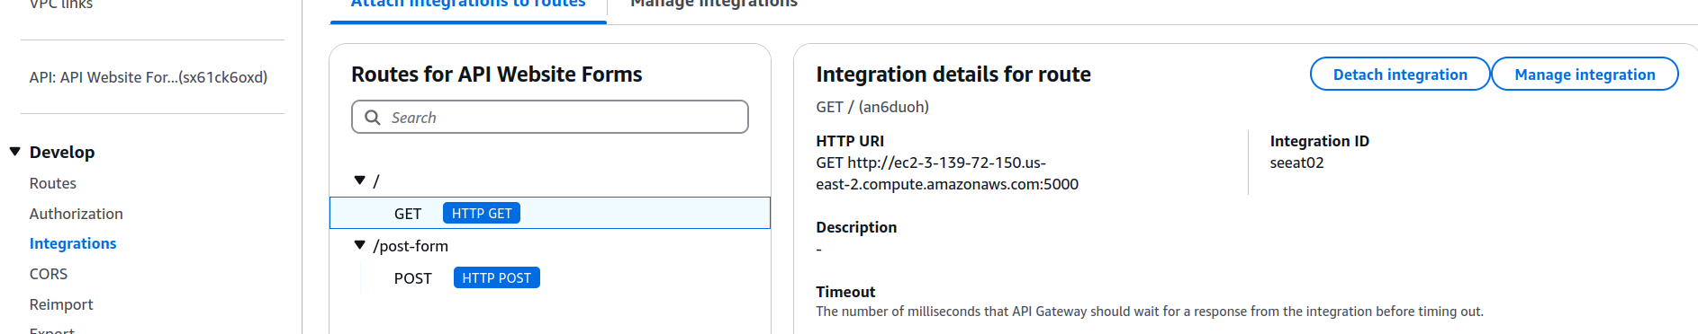

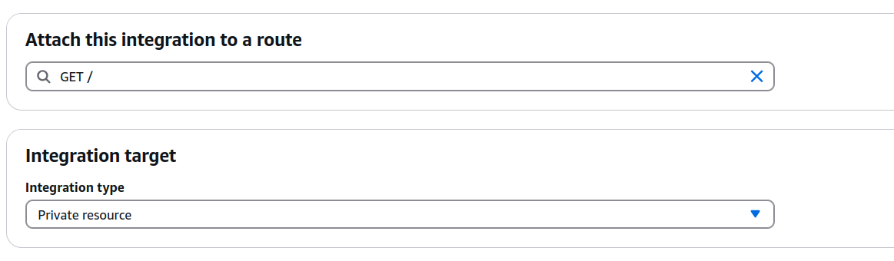

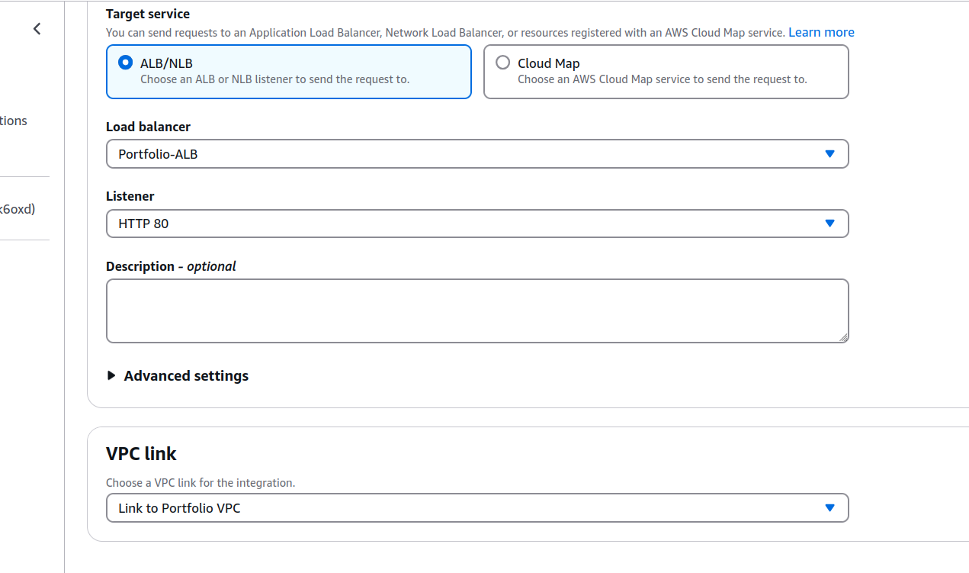

Now try connecting

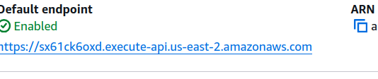

Works! Now do the same with the /post-form route.

End questions:

What security improvements did we add?

Where are some weakpoints in security that could possibly be exploited still?